Practicum Case | 
COMP6885 | COMP6885001
Natural Language Processing
Computer Science | O251-COMP6885-JD01-10
Valid on Odd Semester Year 2024/2025 | Revision 00

Learning Outcomes
- LO2 - explain Explain fundamental concepts of how to work with Natural Language Processing
- LO3 - apply Natural Language Processing concepts in certain real-world applications
- LO4 - construct Natural Language Processing applications

Topic
- Session 10 - Dependency Parsing with SpaCy

Sub Topics
- Dependency Parsing with SpaCy

Soal
Case
Learning Parsing with SpaCy

You have a senior programmer that taught you how to use SpaCy for parsing sentences. Your task is to review the process by doing this step:
- First you will use this data in your code:
sentence = 'Budiman Goodboy is so genius, he can defeat everyone in Bina Nusantara at coding'

- Parse that sentence using spacy package ‘en_core_web_sm’.
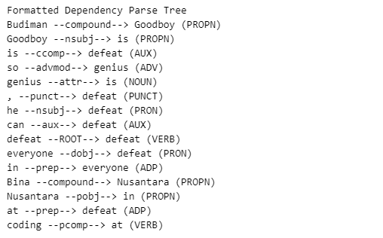
Figure 1. Result

